Practical No 1: Simple Calculator

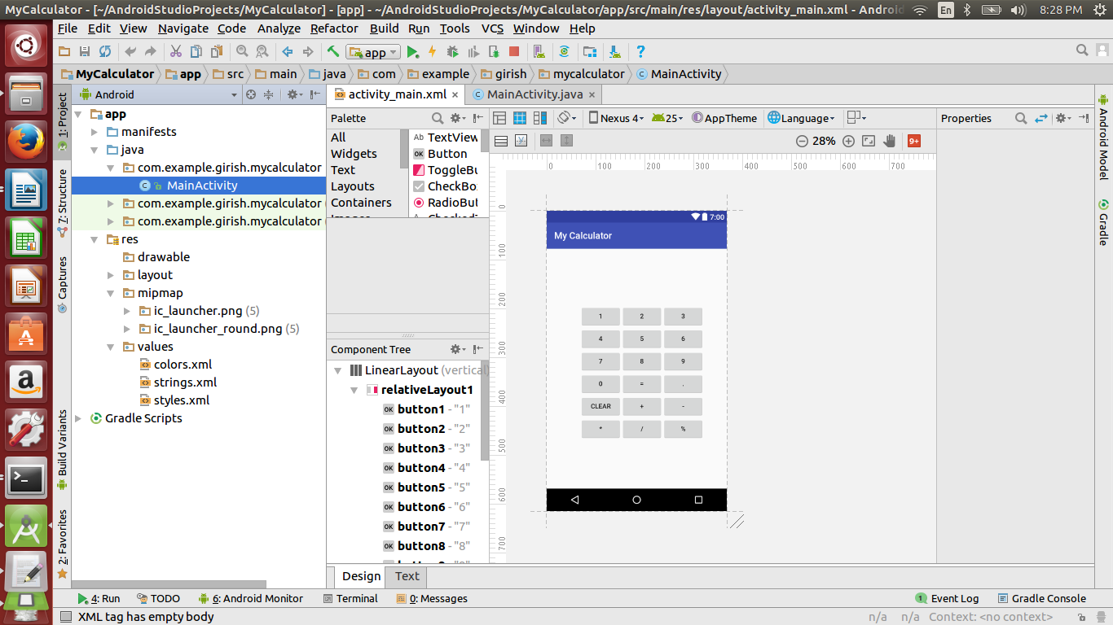

**activity_main.xml**

*<?***xml version="1.0" encoding="utf-8"** *?>*

<**LinearLayout xmlns:android="http://schemas.android.com/apk/res/android"**

**android:layout_width="fill_parent"**

**android:layout_height="fill_parent"**

**android:orientation="vertical"**>

<**RelativeLayout**

**android:id="@+id/relativeLayout1"**

**android:layout_width="312dp"**

**android:layout_height="wrap_content"**

**android:layout_gravity="center"**

**android:layout_marginLeft="35dp"**>

<**Button**

**android:id="@+id/button1"**

**android:layout_width="wrap_content"**

**android:layout_height="wrap_content"**

**android:layout_alignParentLeft="true"**

**android:layout_marginTop="150dp"**

**android:padding="20px"**

**android:text="1"**></**Button**>

<**Button**

**android:id="@+id/button2"**

**android:layout_width="wrap_content"**

**android:layout_height="wrap_content"**

**android:layout_alignTop="@+id/button1"**

**android:layout_toRightOf="@+id/button1"**

**android:padding="20px"**

**android:text="2"**></**Button**>

<**Button**

**android:id="@+id/button3"**

**android:layout_width="wrap_content"**

**android:layout_height="wrap_content"**

**android:layout_alignTop="@+id/button2"**

**android:layout_toRightOf="@+id/button2"**

**android:padding="20px"**

**android:text="3"**></**Button**>

<**Button**

**android:id="@+id/button4"**

**android:layout_width="wrap_content"**

**android:layout_height="wrap_content"**

**android:layout_alignParentLeft="true"**

**android:layout_below="@+id/button1"**

**android:padding="20px"**

**android:text="4"**></**Button**>

<**Button**

**android:id="@+id/button5"**

**android:layout_width="wrap_content"**

**android:layout_height="wrap_content"**

**android:layout_alignTop="@+id/button4"**

**android:layout_toRightOf="@+id/button4"**

**android:padding="20px"**

**android:text="5"**></**Button**>

<**Button**

**android:id="@+id/button6"**

**android:layout_width="wrap_content"**

**android:layout_height="wrap_content"**

**android:layout_alignTop="@+id/button4"**

**android:layout_toRightOf="@+id/button5"**

**android:padding="20px"**

**android:text="6"**></**Button**>

<**Button**

**android:id="@+id/button7"**

**android:layout_width="wrap_content"**

**android:layout_height="wrap_content"**

**android:layout_alignParentLeft="true"**

**android:layout_below="@+id/button4"**

**android:padding="20px"**

**android:text="7"**></**Button**>

<**Button**

**android:id="@+id/button8"**

**android:layout_width="wrap_content"**

**android:layout_height="wrap_content"**

**android:layout_alignTop="@+id/button7"**

**android:layout_toRightOf="@+id/button7"**

**android:padding="20px"**

**android:text="8"**></**Button**>

<**Button**

**android:id="@+id/button9"**

**android:layout_width="wrap_content"**

**android:layout_height="wrap_content"**

**android:layout_alignTop="@+id/button7"**

**android:layout_toRightOf="@+id/button8"**

**android:padding="20px"**

**android:text="9"**></**Button**>

<**Button**

**android:id="@+id/button0"**

**android:layout_width="wrap_content"**

**android:layout_height="wrap_content"**

**android:layout_alignParentLeft="true"**

**android:layout_below="@+id/button7"**

**android:padding="20px"**

**android:text="0"**></**Button**>

<**Button**

**android:id="@+id/button15"**

**android:layout_width="wrap_content"**

**android:layout_height="wrap_content"**

**android:layout_alignTop="@+id/button0"**

**android:layout_toRightOf="@+id/button0"**

**android:padding="20px"**

**android:text="="**></**Button**>

<**Button**

**android:id="@+id/button18"**

**android:layout_width="wrap_content"**

**android:layout_height="wrap_content"**

**android:layout_alignTop="@+id/button0"**

**android:layout_toRightOf="@+id/button15"**

**android:padding="20px"**

**android:text="."**></**Button**>

<**Button**

**android:id="@+id/button16"**

**android:layout_width="wrap_content"**

**android:layout_height="wrap_content"**

**android:layout_alignParentLeft="true"**

**android:layout_below="@+id/button0"**

**android:padding="20px"**

**android:text="clear"**></**Button**>

<**Button**

**android:id="@+id/button11"**

**android:layout_width="wrap_content"**

**android:layout_height="wrap_content"**

**android:layout_alignTop="@+id/button16"**

**android:layout_toRightOf="@+id/button16"**

**android:padding="20px"**

**android:text="+"**></**Button**>

<**Button**

**android:id="@+id/button12"**

**android:layout_width="wrap_content"**

**android:layout_height="wrap_content"**

**android:layout_alignTop="@+id/button16"**

**android:layout_toRightOf="@+id/button11"**

**android:padding="20px"**

**android:text="-"**></**Button**>

<**Button**

**android:id="@+id/button13"**

**android:layout_width="wrap_content"**

**android:layout_height="wrap_content"**

**android:layout_alignParentLeft="true"**

**android:layout_below="@+id/button16"**

**android:padding="20px"**

**android:text="*"**></**Button**>

<**Button**

**android:id="@+id/button14"**

**android:layout_width="wrap_content"**

**android:layout_height="wrap_content"**

**android:layout_alignTop="@+id/button13"**

**android:layout_toRightOf="@+id/button13"**

**android:padding="20px"**

**android:text="/"**></**Button**>

<**Button**

**android:id="@+id/button17"**

**android:layout_width="wrap_content"**

**android:layout_height="wrap_content"**

**android:layout_alignTop="@+id/button13"**

**android:layout_toRightOf="@+id/button14"**

**android:padding="20px"**

**android:text="%"**></**Button**>

<**TextView**

**android:id="@+id/TextView1"**

**android:layout_width="fill_parent"**

**android:layout_height="wrap_content"**

**android:layout_below="@+id/button13"**

**android:fontFamily="serif"**

**android:textSize="30dp"**></**TextView**>

</**RelativeLayout**>

</**LinearLayout**>

**MainAtivity.java**

**package** com.example.girish.mycalculator;

**import** android.app.Activity;

**import** android.os.Bundle;

**import** android.view.View;

**import** android.widget.Button;

**import** android.widget.TextView;

**import** android.widget.Toast;

**public class** MainActivity **extends** Activity {

TextView **tv1**;

Integer **c**, **d**, **r**, **b**;

String **a** = **"0"**, **aa**;

Button **b1**, **b2**, **b3**, **b4**, **b5**, **b6**, **b7**, **b8**, **b9**, **b10**, **b11**, **b12**, **b13**, **b14**, **b15**, **b16**,**b17**,**b18**;

@Override

**public void** onCreate(Bundle savedInstanceState) {

**super**.onCreate(savedInstanceState);

setContentView(R.layout.***activity_main***);

**tv1** = (TextView) findViewById(R.id.***TextView1***);

**b1** = (Button) findViewById(R.id.***button1***);

**b2** = (Button) findViewById(R.id.***button2***);

**b3** = (Button) findViewById(R.id.***button3***);

**b4** = (Button) findViewById(R.id.***button4***);

**b5** = (Button) findViewById(R.id.***button5***);

**b6** = (Button) findViewById(R.id.***button6***);

**b7** = (Button) findViewById(R.id.***button7***);

**b8** = (Button) findViewById(R.id.***button8***);

**b9** = (Button) findViewById(R.id.***button9***);

**b10** = (Button) findViewById(R.id.***button0***);

**b11** = (Button) findViewById(R.id.***button11***);

**b12** = (Button) findViewById(R.id.***button12***);

**b13** = (Button) findViewById(R.id.***button13***);

**b14** = (Button) findViewById(R.id.***button14***);

**b15** = (Button) findViewById(R.id.***button15***);

**b16** = (Button) findViewById(R.id.***button16***);

**b17** = (Button) findViewById(R.id.***button17***);

**b18** = (Button) findViewById(R.id.***button18***);

**b1**.setOnClickListener(**new** View.OnClickListener() {

**public void** onClick(View v) {

**a** = **tv1**.getText().toString();

**a** = **a** + **"1"**;

**tv1**.setText(**a**);

}

});

**b2**.setOnClickListener(**new** View.OnClickListener() {

**public void** onClick(View v) {

**a** = **tv1**.getText().toString();

**a** = **a** + **"2"**;

**tv1**.setText(**a**);

}

});

**b3**.setOnClickListener(**new** View.OnClickListener() {

**public void** onClick(View v) {

**a** = **tv1**.getText().toString();

**a** = **a** + **"3"**;

**tv1**.setText(**a**);

}

});

**b4**.setOnClickListener(**new** View.OnClickListener() {

**public void** onClick(View v) {

**a** = **tv1**.getText().toString();

**a** = **a** + **"4"**;

**tv1**.setText(**a**);

}

});

**b5**.setOnClickListener(**new** View.OnClickListener() {

**public void** onClick(View v) {

**a** = **tv1**.getText().toString();

**a** = **a** + **"5"**;

**tv1**.setText(**a**);

}

});

**b6**.setOnClickListener(**new** View.OnClickListener() {

**public void** onClick(View v) {

**a** = **tv1**.getText().toString();

**a** = **a** + **"6"**;

**tv1**.setText(**a**);

}

});

**b7**.setOnClickListener(**new** View.OnClickListener() {

**public void** onClick(View v) {

**a** = **tv1**.getText().toString();

**a** = **a** + **"7"**;

**tv1**.setText(**a**);

}

});

**b8**.setOnClickListener(**new** View.OnClickListener() {

**public void** onClick(View v) {

**a** = **tv1**.getText().toString();

**a** = **a** + **"8"**;

**tv1**.setText(**a**);

}

});

**b9**.setOnClickListener(**new** View.OnClickListener() {

**public void** onClick(View v) {

**a** = **tv1**.getText().toString();

**a** = **a** + **"9"**;

**tv1**.setText(**a**);

}

});

**b10**.setOnClickListener(**new** View.OnClickListener() {

**public void** onClick(View v) {

**a** = **tv1**.getText().toString();

**a** = **a** + **"0"**;

**tv1**.setText(**a**);

}

});

**b11**.setOnClickListener(**new** View.OnClickListener() {

**public void** onClick(View v) {

**aa** = **a**;

**b** = 1;

**a** = **""**;

**tv1**.setText(**"+"**);

**tv1**.setText(**""**);

}

});

**b12**.setOnClickListener(**new** View.OnClickListener() {

**public void** onClick(View v) {

**aa** = **a**;

**b** = 2;

**a** = **""**;

**tv1**.setText(**"-"**);

**tv1**.setText(**""**);

}

});

**b13**.setOnClickListener(**new** View.OnClickListener() {

**public void** onClick(View v) {

**aa** = **a**;

**b** = 3;

**a** = **""**;

**tv1**.setText(**"*"**);

**tv1**.setText(**""**);

}

});

**b14**.setOnClickListener(**new** View.OnClickListener() {

**public void** onClick(View v) {

**aa** = **a**;

**b** = 4;

**a** = **""**;

**tv1**.setText(**"/"**);

**tv1**.setText(**""**);

}

});

**b15**.setOnClickListener(**new** View.OnClickListener() {

**public void** onClick(View v) {

**if** (**b** == 1) {

**c** = Integer.*parseInt*(**aa**);

**d** = Integer.*parseInt*(**a**);

**r** = **c** + **d**;

} **else if** (**b** == 4) {

**c** = Integer.*parseInt*(**aa**);

**d** = Integer.*parseInt*(**a**);

**r** = **c** / **d**;

} **else if** (**b** == 2) {

**c** = Integer.*parseInt*(**aa**);

**d** = Integer.*parseInt*(**a**);

**r** = **c** - **d**;

} **else if** (**b** == 3) {

**c** = Integer.*parseInt*(**aa**);

**d** = Integer.*parseInt*(**a**);

**r** = **c** * **d**;

}

String op=**""**;

**switch** (**b**) {

**case** 1: op=**" + "**;

**break**;

**case** 2: op=**" - "**;

**break**;

**case** 3: op=**" * "**;

**break**;

**case** 4: op=**" / "**;

}

**tv1**.setText(**c** + op + **d** + **" = "** + **r**);

String ans=**c** + op + **d** + **" = "** + **r**;

Toast.*makeText*(MainActivity.**this**, ans, Toast.***LENGTH_LONG***).show();

}

});

**b16**.setOnClickListener(**new** View.OnClickListener() {

**public void** onClick(View v) {

**tv1**.setText(**""**);

}

});

}

}

